770 7th St NW
Sioux Center, IA 51250
Ph: 712.722.1181
Fax: 712.722.0900
info@vbssys.com

Poultry Chain Scale Questionnaire

Company Name: ________________________ Date: ____________

- Desired location of poultry chain scale?
- Slaughter capacity per day?
- How many maximum birds per min?
- Chain speed?
- Distance between trolleys?
- Weight of the largest bird?
- Type of power available?
- Describe the current method of weighing the carcass
- Do you have any drawing or product images you can share (really important)?
- Does your current chain permit isolation of carcass from chain pull forces? (See image below)
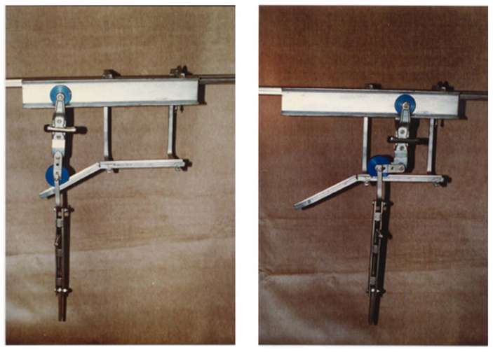
- Other comments

